Use-Case Realization Report
AddUserAdministrator

Issue <1.0>
Revision History
Date | Issue | Description | Author
<02/08/09> | <1.0> | <Add User Administrator> | <Karen Gao>

Table of Contents
1. Brief Description 4
2. Flow of Events 4
2.1 Standard Flow 4
2.2 Exceptions 4
3. Interaction Diagrams 5
3.1 Collaboration Diagram for AddUserAdministrator 5
4. Participating Objects 5
5. Class Diagrams 6
5.1 Class Diagram for AddUserAdministrator 6
6. Derived Requirements 6

Use-Case Realization Report
AddUserAdministrator

Brief Description
The addition of a new User Administrator shall be executed once the duplication check for the existing User Admin list was performed.

Flow of Events

Standard Flow
This use case covers the events of adding User Administrator, which is part of the User Administrator Maintenance package. The standard flow of events is described as below:
- The Portal Administrator shall press the button to send out a command of “AddButtonClicked” on the interface of MaintainUserAdminPage.
- Once MaintainUserAdminController received this request, the operation getUserAdminList will get the User Admin list from object of UserAdmin.
- The MaintainuserAdminController shall perform the check for duplication of record, if not duplication of record is found, it will proceed to the operation getRole from Role object.
- The operation assignRole will assign role to the Customer object according to the desired.
- Then the updateUserAdminList of the MaintainuserAdminController will update the new list of UserAdmin object
- Once it’s done, the successful updating userAdminList will show to the MaintainUserAdminPage.

Exceptions

- If there’s duplication found in User Admin records, a warning message will be show to the MaintainUserAdminPage through the operation showUserAdminDuplicatedMsg.

Interaction Diagrams

Collaboration Diagram for AddUserAdministrator
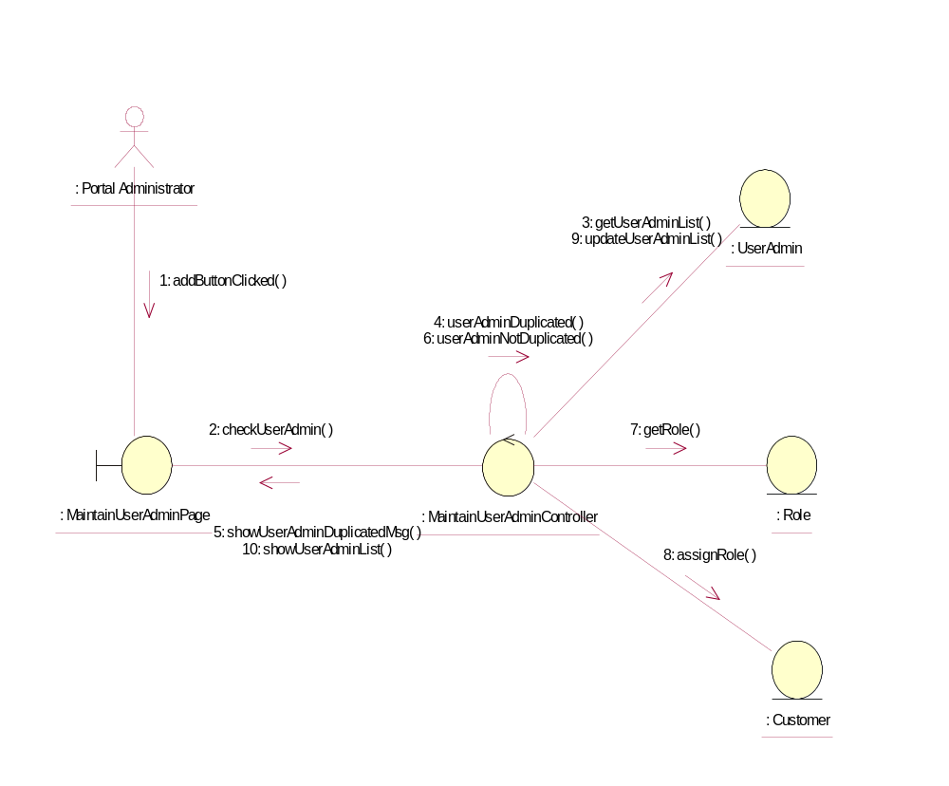

Participating Objects
: Customer
This Entity is Customer object

: MaintainUserAdminController
This controller is to add, delete and update User Administrator

: MaintainUserAdminPage
This is a page for adding, deleting, updating and displaying the User Administrator

: Portal Administrator
This is the super user of the system.

: Role
This Entity is Role object

: UserAdmin
This Entity is UserAdmin Object

Class Diagrams

Class Diagram for AddUserAdministrator
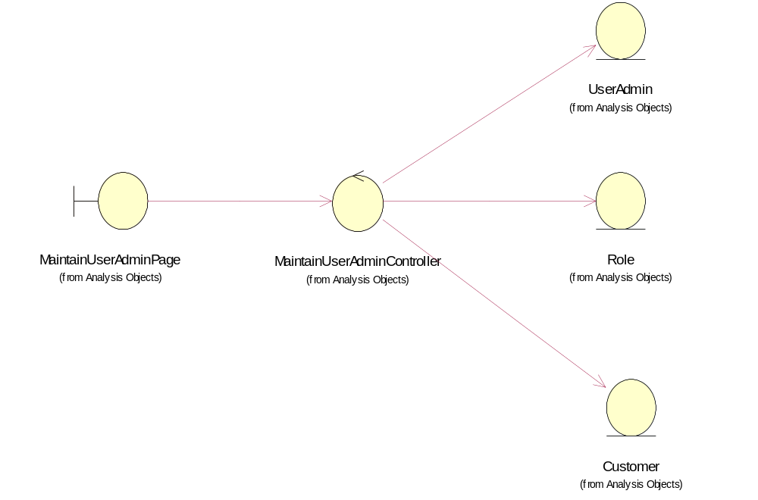

Derived Requirements
Only Portal Administrator can access this page.

